**ABSTRACT**

Biometric authentication is a process of identifying and differentiating individuals for security

purpose that counts on the distinctive physiological and behavioral characteristics of a

person for verification. Dorsal vein pattern is one of the prospective biometrics and we have

made successful use of this biometric feature for authentication purpose. The prime goal has been to establish a method with better Correct Recognition Rate (CRR), low False Acceptance Rate (FAR) and low False Rejection Rate (FRR). Near Infrared (NIR) image of dorsal hand is used, as it provides better resolution of vein pattern in the image than visible light. This recognition system consists of several steps; they are denoising of the input image using Laplacian Scale Mixture Modeling (LSM), Region of Interest (ROI) extraction from denoised image using valley point detection method, contrast enhancement using pyramid based edge aware filtering method, contrast limited adaptive histogram equalization, binarization, several serial morphological operations and finally authentication using neural networks and Support Vector Machine (SVM) classifier. The experiment was initially performed on a database of 16 distinct subjects where there are 10 raw images of each subject taken in different conditions. The accuracy obtained from experimental results is 96.63. The scale of the experiment can be extended for more users, which we believe will yield similar success and thus this method of biometric authentication using dorsal vein pattern can be used in security purpose.

**PRODUCT BACKLOG**



**SPRINT BACKLOG**



**SYSTEM DESIGN**

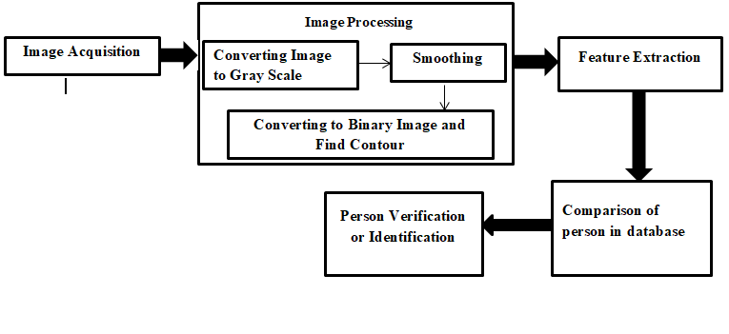

**Level 0:**

User

Dorsal Vein Identification System

Response

Request

**Level 1:**

User

Dorsal Vein Recognition

User

Response

Request

**Level 1.1:**

Visualization

Dorsal Vein

User

User

**Level 1.2:**

Dorsal Vein Recognition

Dorsal Hand Image

User

User